SOFTWARE DESIGN DOCUMENT (SDD)

Service Management System

1. DOCUMENT CONTROL
Item | Details
Project Name | Service management system
Version | 1.0
Author | (Your Name)
Date | (Date)
Status | Final

2. PURPOSE OF THE DOCUMENT
This document describes the system architecture, design decisions, component structure, APIs, data models, and non-functional aspects of the Smart Order Management System.
It is intended for:
- Developers
- Reviewers
- Interview discussions
- Maintenance & enhancement planning

3. SYSTEM OVERVIEW

Business Objective
Provide a scalable, secure, and maintainable system to:
- Manage users
- Manage products
- Place and track orders
- Support growth through microservices

High-Level Features
- User registration & login
- Product catalog management
- Order placement & tracking
- Role-based access (USER / ADMIN)

4. ARCHITECTURE OVERVIEW (HLD)
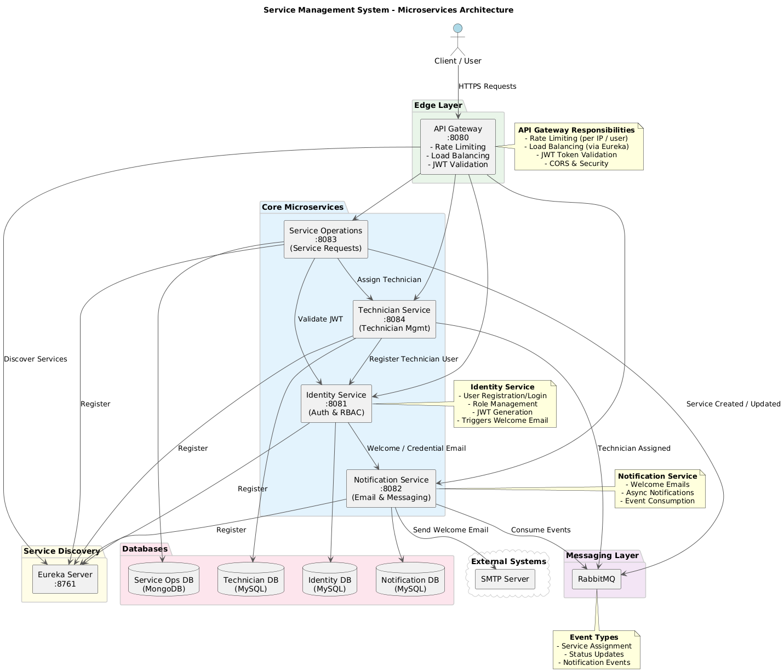

Architecture Style
- Microservices Architecture
- REST-based communication
- Containerized deployment

Core Components
- Angular Frontend
- API Gateway (optional)
- User Service
- Product Service
- Order Service
- MongoDB (per service)
- CI/CD Pipeline

5. TECHNOLOGY STACK

Backend
- Java 17
- Spring Boot
- Spring Web
- Spring Data MongoDB
- Spring Validation

Frontend
- Angular
- Bootstrap
- Angular Material
- RxJS

Database
- MongoDB (one DB per microservice)

DevOps
- Docker
- Docker Compose
- Jenkins
- SonarQube

Testing
- JUnit 5
- Mockito

6. MICROSERVICES DESIGN

CORE INFRASTRUCTURE SERVICES (UNCHANGED)
Service | Port | Responsibility
config-server | 8888 | Centralized configuration management
eureka-server | 8761 | Service discovery and registration
api-gateway | 8080 | Single entry point, JWT validation, routing

BUSINESS SERVICES (FINAL)
Service | Port | Database
identity-service | 8081 | MySQL
service-operations-service | 8083 | MongoDB
technician-service | 8085 | MySQL
notification-service | 8087 | MySQL

IDENTITY-SERVICE (8081)
Purpose
Handles authentication, authorization, staff onboarding, JWT lifecycle, and user profile management.
Database
identity_db (Relational)

Entities
- UserAuth (signup/register)
{
"email": "jane.doe@example.com",
"password": "Str0ngP@ssw0rd!",
"roles": ["CUSTOMER"]
}
- UserProfile (create/update profile)
{
"userId": "user-123",
"firstName": "Jane",
"lastName": "Doe",
"phone": "555-111-2222",
"address": "123 Main St",
"city": "Austin",
"state": "TX",
"zipCode": "78701"
}
- RefreshToken (persist)
{
"userId": "user-123",
"token": "random-refresh-token",
"expiryDate": "2026-01-30T12:00:00Z"
}
Endpoints
Authentication (/api/auth)
Public
- POST /api/auth/login
- POST /api/auth/register → Register Customer
- POST /api/auth/refresh
Authenticated
- GET /api/auth/me
- PUT /api/auth/change-password
- POST /api/auth/logout
Admin
- POST /api/auth/admin/register-manager
- POST /api/auth/admin/register-technician
Manager
- POST /api/auth/manager/register-technician
Debug
- POST /api/auth/debug/test-password

Users (/api/users)
- GET /api/users/{userId}
- GET /api/users/search?email=
- GET /api/users/role/{role}

User Profile (/api/users/profile)
- POST /api/users/profile
- GET /api/users/profile/{userId}
- PUT /api/users/profile/{userId}

Admin Bootstrap

INSERT INTO users (email, password, role, is_active, is_email_verified, created_at)
VALUES (
'admin@servicemanagement.com',
'$2a$10$encrypted_password_hash',
'ADMIN',
true,
true,
NOW()
);

SERVICE-OPERATIONS-SERVICE (8083)
Combines Service Catalog, Service Requests, and Billing
Uses MongoDB for flexible schema and image support.
Database
service_operations_db (MongoDB)

Mongo Collections
- ServiceCategory
{
"id": "cat-001",
"name": "Plumbing",
"description": "All plumbing related services"
}
- ServiceItem
{
"id": "svc-001",
"categoryId": "cat-001",
"name": "Leak Fix",
"description": "Fix leaking pipes",
"basePrice": 120.0,
"active": true
}
ServiceRequest
{
"id": "req-001",
"requestNumber": "SR-2025-0001",
"customerId": "user-123",
"serviceId": "svc-001",
"priority": "HIGH",
"status": "ASSIGNED",
"preferredDate": "2026-01-02T15:00:00Z",
"address": "123 Main St, Austin, TX",
"technicianId": "tech-456",
"assignedAt": "2025-12-31T16:00:00Z",
"completedAt": null,
"createdAt": "2025-12-31T15:45:00Z"
}
- Invoice
{
"id": "inv-001",
"serviceRequestId": "req-001",
"amount": 150.0,
"tax": 12.5,
"total": 162.5,
"status": "PENDING",
"createdAt": "2025-12-31T17:00:00Z",
"paidAt": null
}
TechnicianRating
{
"id": "rate-001",
"serviceRequestId": "req-001",
"technicianId": "tech-456",
"customerId": "user-123",
"rating": 5,
"comments": "Great job, on time and professional",
"createdAt": "2026-01-03T10:00:00Z"
}

Service Requests (/api/service-requests)
Create & View
- POST /api/service-requests
- GET /api/service-requests
- GET /api/service-requests/{id}
Customer Views
- GET /api/service-requests/my-requests
- GET /api/service-requests/my-requests/with-technician
- GET /api/service-requests/customer/{customerId}
- GET /api/service-requests/customer/{customerId}/with-technician
Technician Views
- GET /api/service-requests/technician/my-requests
- GET /api/service-requests/technician/my-requests/with-customer
Status & Lifecycle
- PUT /api/service-requests/{id}/assign
- PUT /api/service-requests/{id}/status
- PUT /api/service-requests/{id}/complete
- PUT /api/service-requests/{id}/cancel
Filters & Stats
- GET /api/service-requests/status/{status}
- GET /api/service-requests/stats

Service Catalog – Services (/api/catalog/services)
- GET /api/catalog/services
- POST /api/catalog/services
- GET /api/catalog/services/{id}
- PUT /api/catalog/services/{id}
- GET /api/catalog/services/category/{categoryId}

Service Catalog – Categories (/api/catalog/categories)
- GET /api/catalog/categories
- POST /api/catalog/categories

Billing – Invoices (/api/billing/invoices)
Create & Fetch
- POST /api/billing/invoices
- GET /api/billing/invoices/{id}
- GET /api/billing/invoices/request/{requestId}
- GET /api/billing/invoices/customer/{customerId}
Payments
- POST /api/billing/invoices/{id}/pay
- PUT /api/billing/invoices/{id}/payment
Reports
- GET /api/billing/reports/revenue

Ratings (/api/ratings)
- POST /api/ratings
- GET /api/ratings/technician/{technicianId}
- GET /api/ratings/technician/{technicianId}/average

TECHNICIAN-SERVICE (8085)
Purpose
Manages technician profiles, availability, workload, and scheduling.
Database
technician_db (Relational)

Entities
TechnicianApplication(apply)
{
"fullName": "John Michael Smith",
"email": "john.smith@example.com",
"phone": "555-123-4567",
"address": "1234 Oak Street, Apt 5B",
"city": "Austin",
"state": "Texas",
"zipCode": "78701",
"experience": 8,
"specialization": "Plumbing",
"skills": ["Pipe Installation", "Water Heater Repair", "Drain Cleaning"],
"certifications": "Licensed Master Plumber",
"previousEmployer": "ABC Plumbing Services",
"workExperienceDetails": "8 years handling residential and commercial jobs.",
"maxWorkload": 5,
"motivation": "Join a quality-focused team.",
"hasVehicle": true,
"hasToolkit": true,
"availability": "Mon-Fri 8AM-6PM",
"emergencyContactName": "Sarah Smith",
"emergencyContactPhone": "555-987-6543"
}
TechnicianProfile
{
"userId": "user-tech-001",
"email": "john.smith@example.com",
"phone": "555-123-4567",
"specialization": "Plumbing",
"experience": 8,
"rating": 4.9,
"skills": ["Pipe Installation", "Drain Cleaning", "Leak Detection"],
"isAvailable": true,
"currentWorkload": 1,
"location": "Austin, TX",
"maxWorkload": 5
}
TechnicianSchedule
{
"id": "sched-001",
"technicianId": "tech-456",
"date": "2026-01-02",
"slots": [
{"from": "09:00", "to": "11:00", "booked": true, "serviceRequestId": "req-001"},
{"from": "12:00", "to": "14:00", "booked": false}
]
}
Technician Profiles (/api/technicians)
Profile Management
- POST /api/technicians/profile
- GET /api/technicians/profile/{id}
- GET /api/technicians/{id}
- GET /api/technicians/by-user/{userId}
Availability & Rating
- PUT /api/technicians/{id}/availability
- PUT /api/technicians/{id}/rating
Discovery
- GET /api/technicians/available

Technician Applications (/api/technicians/applications)
Apply
- POST /api/technicians/apply
Review (Admin / Manager)
- GET /api/technicians/applications/pending
- POST /api/technicians/applications/{id}/approve
- POST /api/technicians/applications/{id}/reject

Workload & Stats
Workload
- GET /api/technicians/{id}/workload
System Stats
- GET /api/technicians/stats

NOTIFICATION-SERVICE (8087)
Purpose
Email and in-app notifications, staff credential delivery.
Database
notification_db (Relational)

Entities
- Notification (create)
{
"userId": "user-123",
"type": "IN_APP",
"title": "Technician Assigned",
"subject": "Your service request was assigned",
"message": "Technician John Smith will arrive tomorrow at 10 AM.",
"isRead": false,
"sentAt": "2025-12-31T15:30:00Z"
}
- EmailLog (record)
{
"toEmail": "jane.doe@example.com",
"subject": "Welcome!",
"body": "Thanks for signing up.",
"status": "SENT",
"sentAt": "2025-12-31T15:31:00Z",
"error": null
}
Endpoints
Method | Endpoint
POST | /api/notifications/send
POST | /api/notifications/send-credentials
GET | /api/notifications/user/{userId}
PUT | /api/notifications/{id}/read

- DATA DESIGN (LLD)
ER diagram
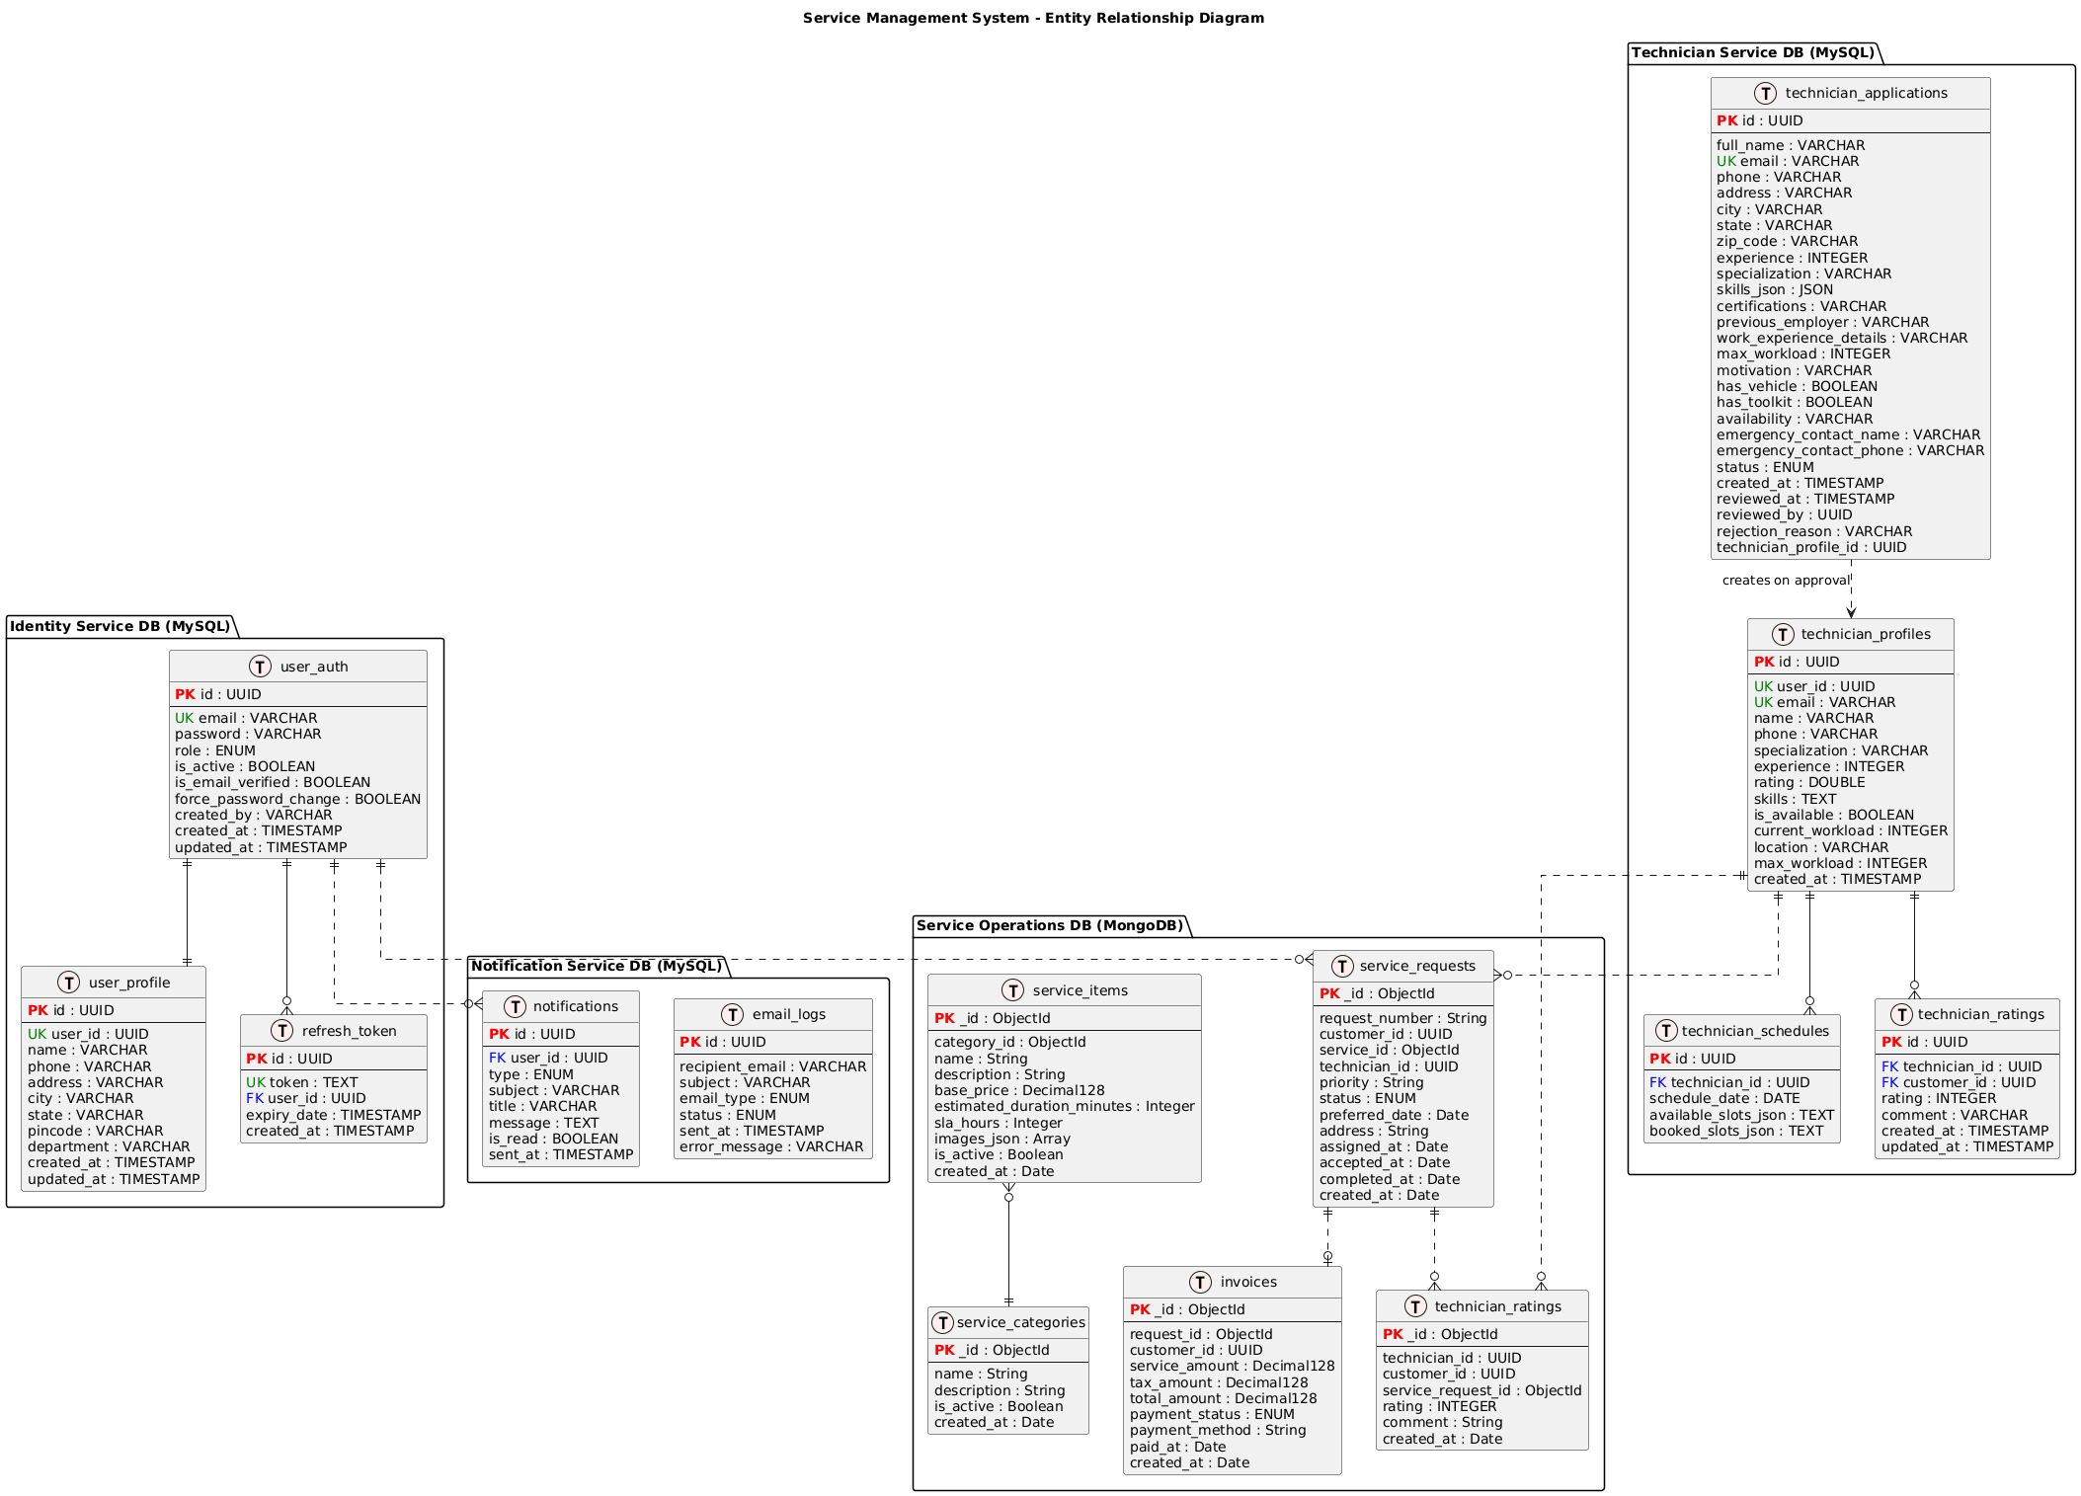

8. API DESIGN & VALIDATION
- RESTful principles
- JSON request/response
- Bean Validation at DTO layer
- Service-level business rule enforcement
- Standard HTTP status codes

9. ERROR HANDLING STRATEGY

Global Exception Handling
- Centralized using @ControllerAdvice
- Standard error response format
{
"timestamp": "2025-01-01T10:00:00",
"status": 400,
"error": "Validation Error",
"message": "Price must be greater than zero"
}

10. SECURITY DESIGN
- Password encryption (BCrypt)
- Role-based access control
- JWT authentication (optional enhancement)
- Secure API access

11. NON-FUNCTIONAL REQUIREMENTS
Area | Design Decision
Scalability | Stateless services, Docker
Performance | Pagination, async calls
Availability | Independent services
Maintainability | POM-like layered backend
Security | Validation, encryption
Observability | Logging & monitoring

12. TESTING STRATEGY

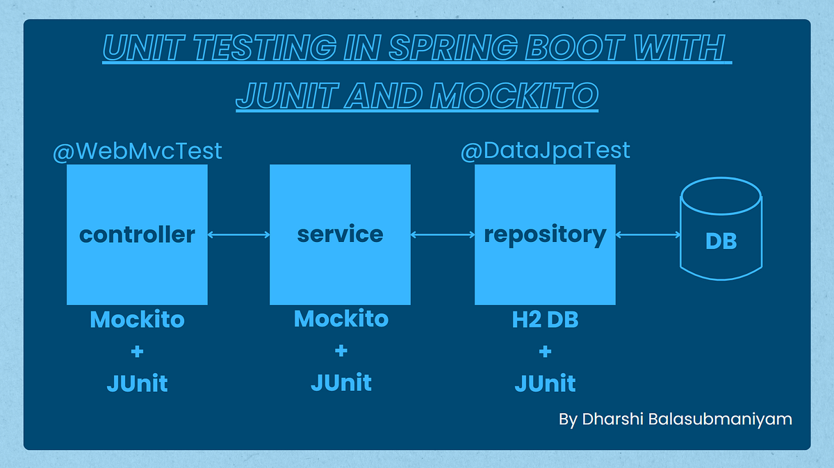

Backend
- Unit tests (Service layer)
- Controller tests (MockMvc)
- Minimum 90% coverage

Frontend
- Component tests
- Service tests

Quality Gates
- SonarQube enforced
- Build fails on violations

13. CI/CD DESIGN
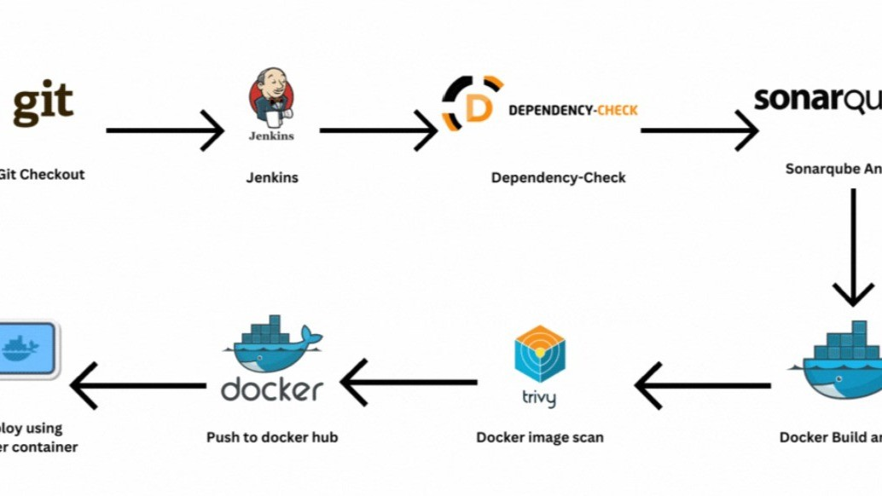
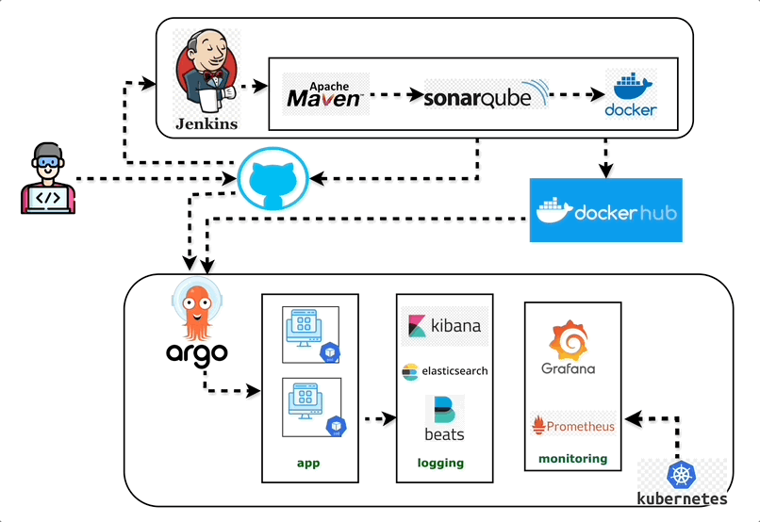

Pipeline Flow
- Git Commit
- Jenkins Build
- Unit Tests
- SonarQube Scan
- Quality Gate Check
- Docker Build
- Docker Compose Deploy

14. DEPLOYMENT DESIGN
- Docker image per microservice
- docker-compose for orchestration
- Environment-specific configs

15. ASSUMPTIONS & CONSTRAINTS

Assumptions
- Services communicate over REST
- MongoDB available
- Docker environment present

Constraints
- No distributed transactions
- Event-driven architecture out of scope

16. FUTURE ENHANCEMENTS
- Spring Cloud Gateway
- Kafka-based async communication
- Kubernetes deployment
- Centralized logging (ELK)

17. CONCLUSION
This design ensures:
✔ Clean separation of concerns
✔ Scalability & maintainability
✔ Testability & CI/CD readiness
✔ Interview-ready explanation
SEQUENCE DIAGRAMS — SMART ORDER MANAGEMENT SYSTEM
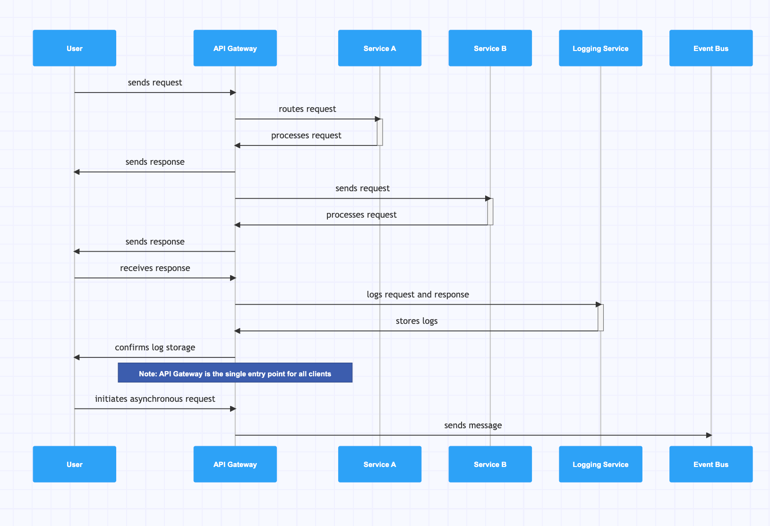
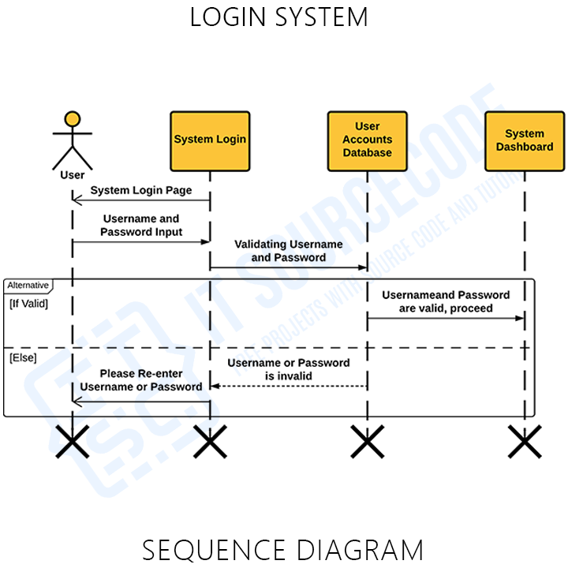
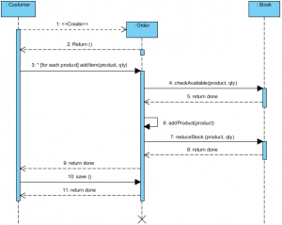

1. User Registration — Sequence Diagram

Scenario
A new user registers using the Angular UI.

Flow
- User enters details in Angular UI
- Angular sends POST /users/register to User Service
- User Service validates request (email, password)
- User Service checks email uniqueness in MongoDB
- Password is encrypted
- User is saved in MongoDB
- Success response sent back to UI

Participants
- User
- Angular UI
- User Service
- MongoDB

Key Design Points
- Validation at API boundary
- Encryption at service layer
- No direct DB access from UI

2. User Login — Sequence Diagram
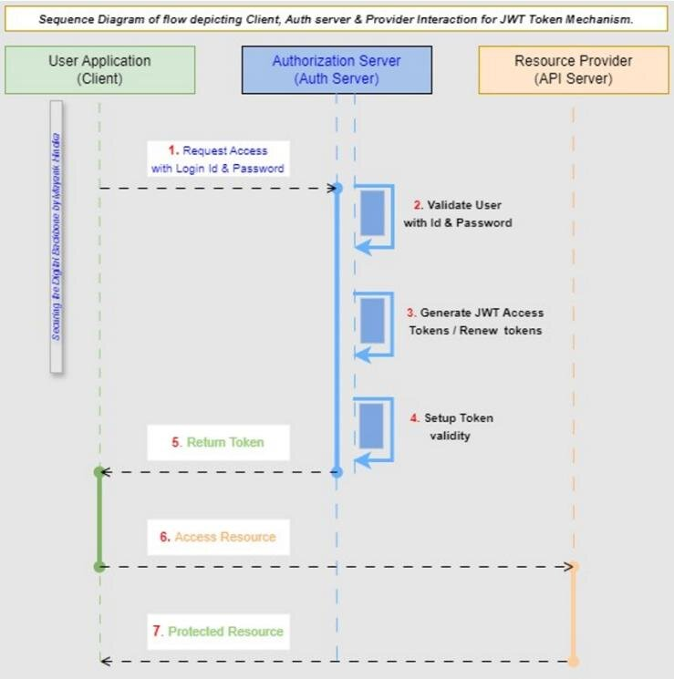

Scenario
Registered user logs into the system.

Flow
- User submits login form
- Angular calls POST /users/login
- User Service fetches user from MongoDB
- Password is verified
- (Optional) JWT token generated
- Response sent to Angular
- Angular stores token and navigates user

Participants
- User
- Angular UI
- User Service
- MongoDB

Failure Cases
- Invalid credentials → 401
- Inactive user → 403

3. Product Listing — Sequence Diagram
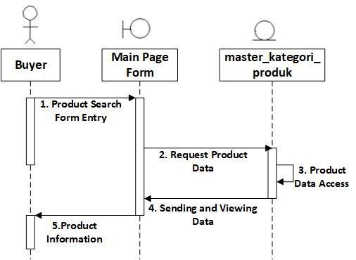
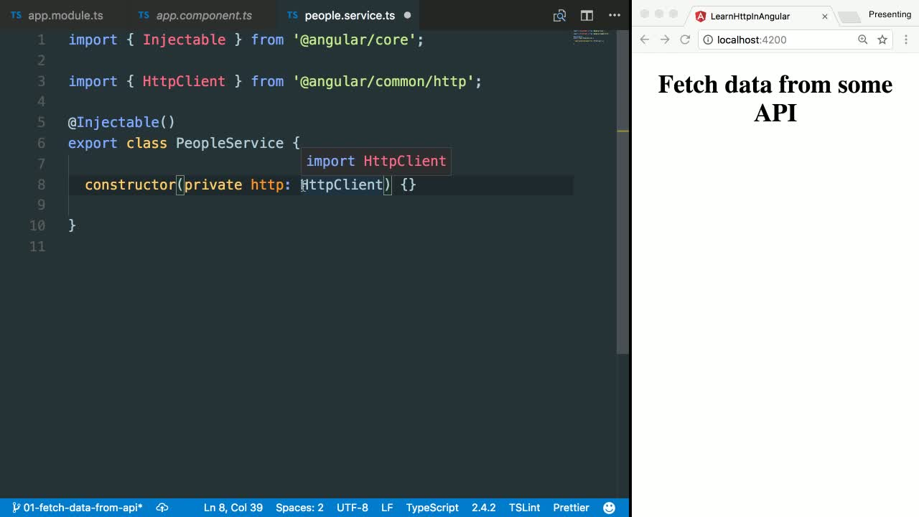

Scenario
User views available products.

Flow
- Angular loads product page
- GET /products sent to Product Service
- Product Service queries MongoDB
- Product list returned to Angular

Participants
- Angular UI
- Product Service
- MongoDB

4. Order Placement — Sequence Diagram (MOST IMPORTANT)
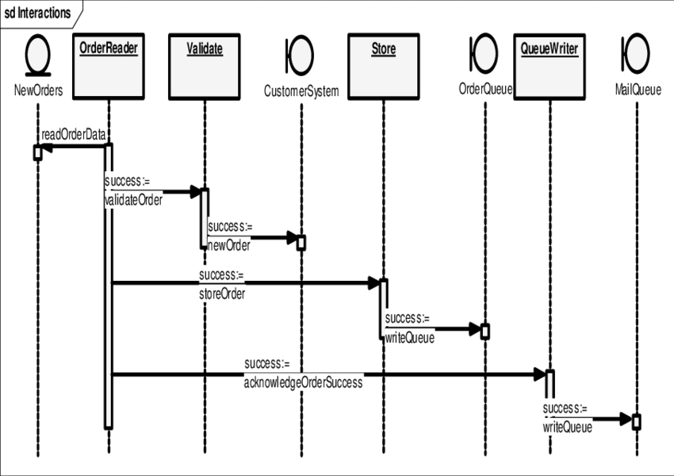
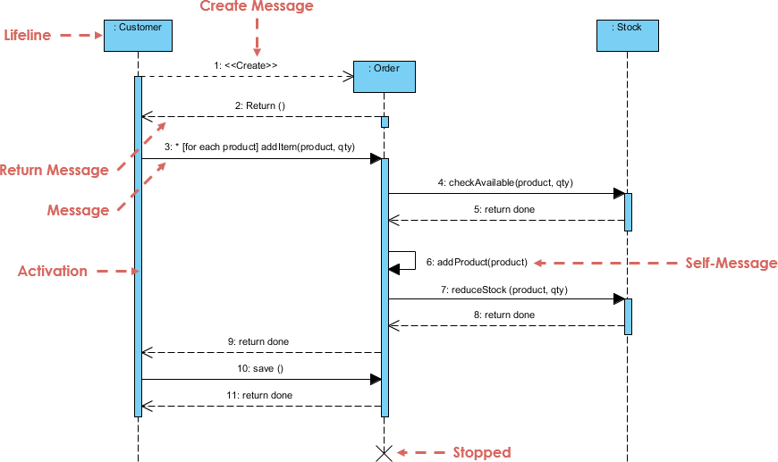

Scenario
User places an order for one or more products.

Flow
- User clicks Place Order in Angular
- Angular sends POST /orders to Order Service
- Order Service validates request
- Order Service calls Product Service to check stock
- Product Service validates availability
- Order Service creates order
- Product Service reduces inventory
- Order saved in MongoDB
- Success response returned to Angular

Participants
- User
- Angular UI
- Order Service
- Product Service
- MongoDB

Key Design Decisions
- Inventory validation before order creation
- Atomic stock update logic
- Failure stops order creation

5. Order Status Update (Admin) — Sequence Diagram

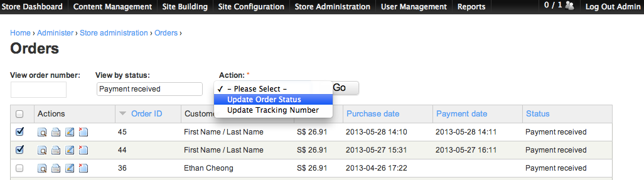

Scenario
Admin updates order status.

Flow
- Admin sends update request from Angular
- PUT /orders/{id}/status sent to Order Service
- Role validation (ADMIN only)
- Order status transition validated
- Order updated in MongoDB
- Updated status returned

Valid Transitions
- CREATED → PLACED
- PLACED → COMPLETED
- PLACED → CANCELLED

6. CI/CD Pipeline — Sequence Diagram
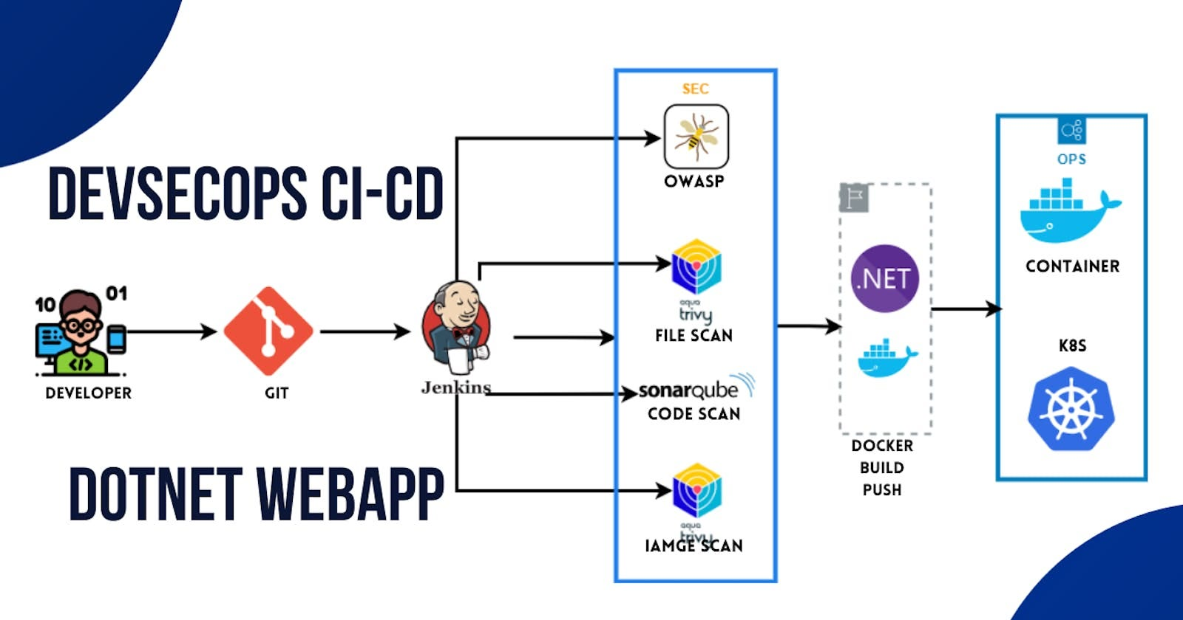

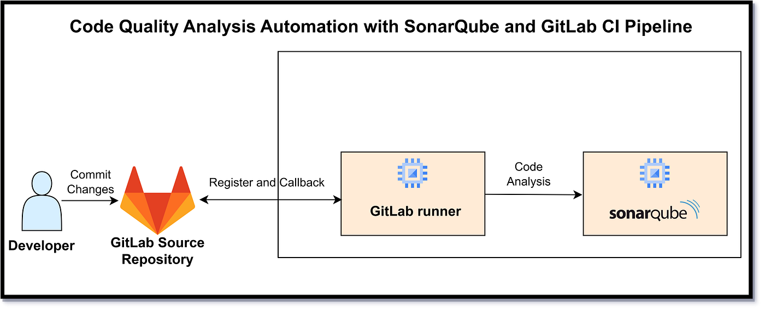

Scenario
Developer pushes code to Git repository.

Flow
- Developer pushes code
- Jenkins pipeline triggered
- Jenkins runs unit tests
- Jenkins runs SonarQube scan
- Quality gate checked
- Docker images built
- Docker Compose deploys services

Participants
- Developer
- Git
- Jenkins
- SonarQube
- Docker

7. Error Handling — Sequence Diagram

Scenario
Invalid request sent to backend.

Flow
- Angular sends invalid request
- Controller validation fails
- Global exception handler triggered
- Standard error response returned

Key Point
- Consistent error structure across services

HOW TO EXPLAIN IN INTERVIEWS
“We use sequence diagrams to show runtime behavior.
Each diagram highlights service boundaries, validation points, and data ownership, ensuring clean microservices communication.”

----- upto here ------

SEQUENCE → CODE CLASS MAPPING

1) User Registration

Sequence Steps
- User submits registration form
- API receives request
- Validate input & business rules
- Encrypt password
- Persist user
- Return response

Code Mapping (User Service)
Step | Layer | Class | Responsibility
1 | Angular | RegisterComponent | Collect form data
2 | Angular | AuthService | POST /users/register
3 | API | UserController | Request mapping
4 | DTO | UserRegisterRequest | Bean validation
5 | Service | UserService | Uniqueness checks
6 | Security | PasswordEncoderConfig | BCrypt encryption
7 | Repo | UserRepository | Save user
8 | API | UserController | Return response
Key Methods
- UserController.register(UserRegisterRequest)
- UserService.registerUser(...)
- UserRepository.existsByEmail(...)

2) User Login

Sequence Steps
- Submit credentials
- Fetch user
- Verify password
- Generate token (optional)
- Return auth response

Code Mapping
Step | Layer | Class | Responsibility
1 | Angular | LoginComponent | Capture credentials
2 | Angular | AuthService | POST /users/login
3 | API | AuthController | Handle login
4 | Repo | UserRepository | Find by email
5 | Service | AuthService | Password match
6 | Security | JwtTokenProvider | Create JWT
7 | API | AuthController | Return token
Key Methods
- AuthController.login(LoginRequest)
- AuthService.authenticate(...)

3) Product Listing

Sequence Steps
- UI requests products
- Fetch from DB
- Return list

Code Mapping (Product Service)
Step | Layer | Class | Responsibility
1 | Angular | ProductListComponent | Load products
2 | Angular | ProductApiService | GET /products
3 | API | ProductController | Handle request
4 | Service | ProductService | Business logic
5 | Repo | ProductRepository | Query MongoDB
Key Methods
- ProductController.getAllProducts()
- ProductService.findAll()

4) Order Placement (Critical Flow)

Sequence Steps
- Place order
- Validate request
- Check stock
- Reduce inventory
- Create order
- Persist & respond

Code Mapping (Order + Product Services)
Step | Service | Class | Responsibility
1 | Angular | CheckoutComponent | Submit order
2 | Angular | OrderApiService | POST /orders
3 | Order API | OrderController | Receive order
4 | DTO | OrderRequest | Validate payload
5 | Order Svc | OrderService | Orchestrate flow
6 | Order Svc | ProductClient | Call Product Service
7 | Product API | ProductController | Validate stock
8 | Product Svc | InventoryService | Deduct quantity
9 | Order Repo | OrderRepository | Save order
10 | Order API | OrderController | Return result
Key Methods
- OrderService.placeOrder(OrderRequest)
- ProductClient.checkAndReserveStock(...)
- InventoryService.reduceStock(...)

5) Order Status Update (Admin)

Sequence Steps
- Admin updates status
- Validate role
- Validate transition
- Update order

Code Mapping
Step | Layer | Class | Responsibility
1 | Angular | AdminOrderComponent | Update status
2 | Angular | OrderApiService | PUT /orders/{id}/status
3 | Security | JwtAuthFilter | Role validation
4 | API | OrderController | Accept request
5 | Service | OrderService | Validate transition
6 | Repo | OrderRepository | Persist status
Key Methods
- OrderService.updateStatus(orderId, status)
- OrderStatusValidator.isValidTransition(...)

6) Global Validation & Error Handling

Sequence Steps
- Invalid input
- Validation fails
- Standard error response

Code Mapping
Step | Layer | Class | Responsibility
1 | DTO | @Valid annotations | Input validation
2 | Framework | MethodArgumentNotValidException | Triggered
3 | API | GlobalExceptionHandler | Build error response
Key Classes
- GlobalExceptionHandler
- ApiErrorResponse

7) CI/CD with SonarQube

Sequence Steps
- Git push
- Build & tests
- Sonar scan
- Quality gate
- Docker build
- Deploy

Code/Config Mapping
Step | Tool | File/Class
1 | Git | Repository
2 | Jenkins | Jenkinsfile
3 | Maven | pom.xml
4 | SonarQube | sonar-project.properties
5 | Docker | Dockerfile
6 | Compose | docker-compose.yml

TRACEABILITY (WHY THIS MATTERS)
- Sequence step → Controller → Service → Repository
- Every business rule is enforced either in DTO validation or service logic
- Easy to explain end-to-end flow in interviews

How to explain succinctly
“Each sequence diagram step maps directly to a controller endpoint, a service orchestration method, and a repository call. Validation is enforced at DTO and service layers, and failures are handled centrally.”
CODE SKELETON — PACKAGES & CLASSES

1. USER SERVICE (user-service)
user-service
└─ src/main/java/com/example/user
├─ UserServiceApplication.java
│
├─ controller
│ └─ UserController.java
│
├─ service
│ ├─ UserService.java
│ └─ UserServiceImpl.java
│
├─ repository
│ └─ UserRepository.java
│
├─ model
│ └─ User.java
│
├─ dto
│ ├─ UserRegisterRequest.java
│ ├─ LoginRequest.java
│ └─ UserResponse.java
│
├─ exception
│ ├─ UserNotFoundException.java
│ ├─ DuplicateUserException.java
│ └─ GlobalExceptionHandler.java
│
└─ config
└─ SecurityConfig.java

Key Responsibilities
- UserController → API layer
- UserService → Business rules
- UserRepository → MongoDB access
- SecurityConfig → Password encoding / JWT (optional)

2. PRODUCT SERVICE (product-service)
product-service
└─ src/main/java/com/example/product
├─ ProductServiceApplication.java
│
├─ controller
│ └─ ProductController.java
│
├─ service
│ ├─ ProductService.java
│ ├─ ProductServiceImpl.java
│ └─ InventoryService.java
│
├─ repository
│ └─ ProductRepository.java
│
├─ model
│ └─ Product.java
│
├─ dto
│ ├─ ProductRequest.java
│ └─ ProductResponse.java
│
└─ exception
├─ ProductNotFoundException.java
└─ GlobalExceptionHandler.java

Key Responsibilities
- InventoryService → Stock validation & update
- ProductServiceImpl → Core business logic

3. ORDER SERVICE (order-service)
order-service
└─ src/main/java/com/example/order
├─ OrderServiceApplication.java
│
├─ controller
│ └─ OrderController.java
│
├─ service
│ ├─ OrderService.java
│ ├─ OrderServiceImpl.java
│ └─ OrderStatusValidator.java
│
├─ client
│ ├─ ProductClient.java
│ └─ UserClient.java
│
├─ repository
│ └─ OrderRepository.java
│
├─ model
│ ├─ Order.java
│ └─ OrderItem.java
│
├─ dto
│ ├─ OrderRequest.java
│ ├─ OrderItemRequest.java
│ └─ OrderResponse.java
│
└─ exception
├─ OrderNotFoundException.java
└─ GlobalExceptionHandler.java

Key Responsibilities
- ProductClient → Calls Product Service
- OrderStatusValidator → Valid status transitions
- OrderServiceImpl → Orchestrates order flow

4. COMMON / SHARED CONCEPTS (Optional)
common
└─ src/main/java/com/example/common
├─ exception
│ └─ ApiErrorResponse.java
│
├─ util
│ └─ Constants.java
│
└─ config
└─ SwaggerConfig.java

5. ANGULAR FRONTEND (angular-ui)
angular-ui
└─ src/app
├─ core
│ ├─ services
│ │ ├─ auth.service.ts
│ │ ├─ product.service.ts
│ │ └─ order.service.ts
│ │
│ └─ guards
│ └─ auth.guard.ts
│
├─ modules
│ ├─ auth
│ │ ├─ login.component.ts
│ │ └─ register.component.ts
│ │
│ ├─ product
│ │ └─ product-list.component.ts
│ │
│ └─ order
│ ├─ checkout.component.ts
│ └─ order-history.component.ts
│
├─ shared
│ └─ models
│ ├─ user.model.ts
│ ├─ product.model.ts
│ └─ order.model.ts
│
└─ app.module.ts

6. TEST STRUCTURE (IMPORTANT)
src/test/java
└─ com/example
├─ controller
│ └─ UserControllerTest.java
├─ service
│ ├─ UserServiceTest.java
│ └─ OrderServiceTest.java
└─ repository
└─ ProductRepositoryTest.java

7. DEVOPS & CI/CD FILES
capstone-project
├─ Jenkinsfile
├─ docker-compose.yml
├─ user-service/Dockerfile
├─ product-service/Dockerfile
├─ order-service/Dockerfile
├─ angular-ui/Dockerfile
└─ README.md

HOW TO EXPLAIN THIS IN INTERVIEWS
“Each microservice follows a layered architecture: Controller → Service → Repository.
Clients handle inter-service communication.
DTOs isolate API contracts.
Business rules live in the service layer.
This makes the system scalable, testable, and maintainable.”

STARTER REPO
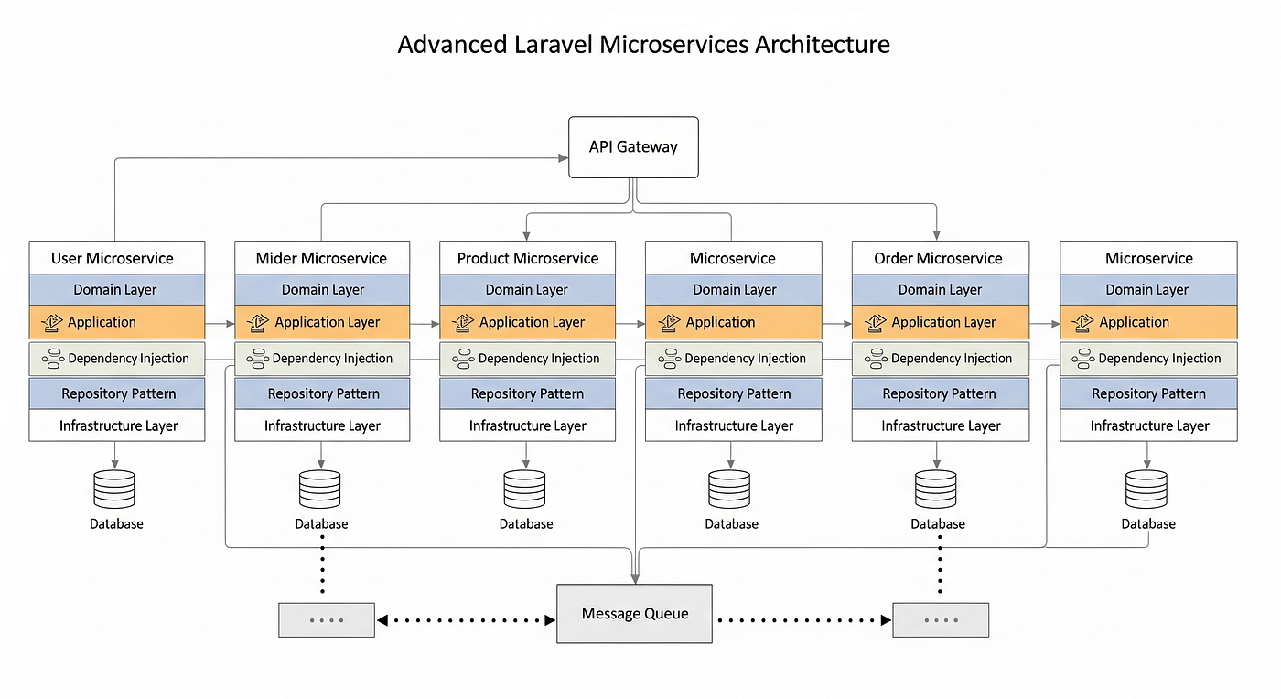

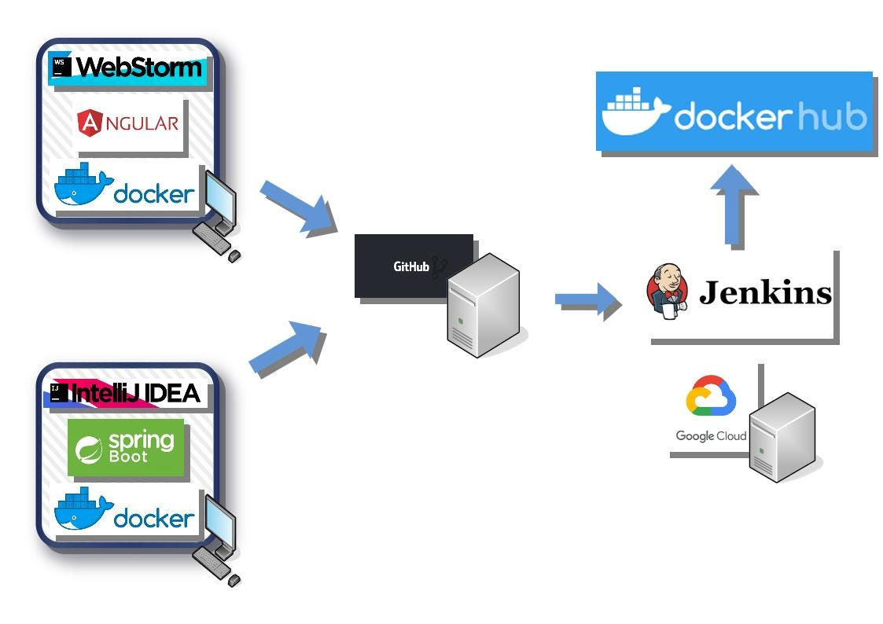

1. REPOSITORY STRUCTURE (ROOT)
smart-order-management/
│
├─ user-service/
├─ product-service/
├─ order-service/
├─ angular-ui/
│
├─ common/
│
├─ docker-compose.yml
├─ Jenkinsfile
├─ .gitignore
├─ README.md
You can create this repo as-is in GitHub.

2. USER SERVICE (Spring Boot)
user-service/
├─ src/main/java/com/example/user
│ ├─ UserServiceApplication.java
│ │
│ ├─ controller
│ │ └─ UserController.java
│ │
│ ├─ service
│ │ ├─ UserService.java
│ │ └─ UserServiceImpl.java
│ │
│ ├─ repository
│ │ └─ UserRepository.java
│ │
│ ├─ model
│ │ └─ User.java
│ │
│ ├─ dto
│ │ ├─ UserRegisterRequest.java
│ │ ├─ LoginRequest.java
│ │ └─ UserResponse.java
│ │
│ ├─ exception
│ │ ├─ DuplicateUserException.java
│ │ └─ GlobalExceptionHandler.java
│ │
│ └─ config
│ └─ SecurityConfig.java
│
├─ src/test/java/com/example/user
│ ├─ controller/UserControllerTest.java
│ └─ service/UserServiceTest.java
│
├─ Dockerfile
├─ pom.xml
└─ application.yml

3. PRODUCT SERVICE
product-service/
├─ src/main/java/com/example/product
│ ├─ ProductServiceApplication.java
│ ├─ controller/ProductController.java
│ ├─ service
│ │ ├─ ProductService.java
│ │ ├─ ProductServiceImpl.java
│ │ └─ InventoryService.java
│ ├─ repository/ProductRepository.java
│ ├─ model/Product.java
│ ├─ dto/ProductRequest.java
│ └─ exception/GlobalExceptionHandler.java
│
├─ src/test/java/com/example/product
│ └─ service/ProductServiceTest.java
│
├─ Dockerfile
├─ pom.xml
└─ application.yml

4. ORDER SERVICE
order-service/
├─ src/main/java/com/example/order
│ ├─ OrderServiceApplication.java
│ ├─ controller/OrderController.java
│ ├─ service
│ │ ├─ OrderService.java
│ │ ├─ OrderServiceImpl.java
│ │ └─ OrderStatusValidator.java
│ ├─ client
│ │ ├─ ProductClient.java
│ │ └─ UserClient.java
│ ├─ repository/OrderRepository.java
│ ├─ model
│ │ ├─ Order.java
│ │ └─ OrderItem.java
│ └─ dto/OrderRequest.java
│
├─ src/test/java/com/example/order
│ └─ service/OrderServiceTest.java
│
├─ Dockerfile
├─ pom.xml
└─ application.yml

5. ANGULAR FRONTEND
angular-ui/
├─ src/app
│ ├─ core
│ │ ├─ services
│ │ │ ├─ auth.service.ts
│ │ │ ├─ product.service.ts
│ │ │ └─ order.service.ts
│ │ └─ guards/auth.guard.ts
│ │
│ ├─ modules
│ │ ├─ auth
│ │ │ ├─ login.component.ts
│ │ │ └─ register.component.ts
│ │ ├─ product/product-list.component.ts
│ │ └─ order/checkout.component.ts
│ │
│ └─ shared/models
│ ├─ user.model.ts
│ ├─ product.model.ts
│ └─ order.model.ts
│
├─ Dockerfile
└─ angular.json

6. DOCKER COMPOSE
version: '3.8'

services:
mongodb:
image: mongo
ports:
- "27017:27017"

user-service:
build: ./user-service
ports:
- "8081:8081"
depends_on:
- mongodb

product-service:
build: ./product-service
ports:
- "8082:8082"
depends_on:
- mongodb

order-service:
build: ./order-service
ports:
- "8083:8083"
depends_on:
- mongodb

angular-ui:
build: ./angular-ui
ports:
- "4200:80"

7. JENKINSFILE (CI/CD + SONARQUBE)
pipeline {
agent any

stages {
stage('Checkout') {
steps { git 'https://github.com/your-org/smart-order-management.git' }
}

stage('Build & Test') {
steps { sh 'mvn clean test' }
}

stage('SonarQube Scan') {
steps {
withSonarQubeEnv('SonarQube') {
sh 'mvn sonar:sonar'
}
}
}

stage('Quality Gate') {
steps {
timeout(time: 2, unit: 'MINUTES') {
waitForQualityGate abortPipeline: true
}
}
}

stage('Docker Build & Deploy') {
steps {
sh 'docker-compose up -d --build'
}
}
}
}

8. README.md (MINIMAL TEMPLATE)
# Smart Order Management System

## Tech Stack
- Spring Boot Microservices
- Angular
- MongoDB
- Docker
- Jenkins + SonarQube

## Run Locally
docker-compose up -d

## Services
- User Service: 8081
- Product Service: 8082
- Order Service: 8083
- UI: http://localhost:4200

Map design → code structure
Tell me what you want to generate next.

